Failed Request Report

# Overview

It fetches the requests which had been failed in last 24 hours of all the BG’s.

# Goal

It is prepared to ease out the process of analyzation of failed requests on daily basis. As we can get it in a simple, CSV format over mail.

# Solution/Logic Design

getRequests(host)

vcacCafeHost

For each request

Fetch request date,request state name

If request state == “failed”

Filter the requests lying in the interval of past 24 hours from the present date

Execute the action “validateScheduledRange”

Fetch request number,request name,request description,request output message,request completion date

Array.push(request number,request,requested by,request date,request completion date,request state,description,request output message)

Write data to the file with the action “write dataToTheFile” and send the file with the mail through workflow “send mail”

end

# Request Properties

* Request Date – Date of the request
* Request – what is the request.
* Request Number
* Request Description – Request in detail
* Request output Message – message after complete processing of a request.
* Request completion Date
* Request Approved Date

Dependencies

# Related Actions

* ValidateScheduledRange – It validates the requests lies within last 24 hours.
* WriteDataToTheFile – It writes the requested data to the provided file.
* regex – It formats the request description and request output message in csv file by eliminating commas and newline with space.

# Related WorkFlows

* Send Mail – It attaches the file with the mail and send it to the requester.

# Related Configuration elements

* fromName – Sender’s name who is sending the mail
* fromAddress – Sender’s email address
* VcacCafeHost – host through which VRO connect with VRA to fetch the required data.
* SmtpHost – with which one will be able to connect to the server to send the mail.
* CcAddress – it includes other member’s mail address to whom requester wants to send the mail.
* smtpPort - with which one will be able to connect to the server to send the mail.

# Attributes

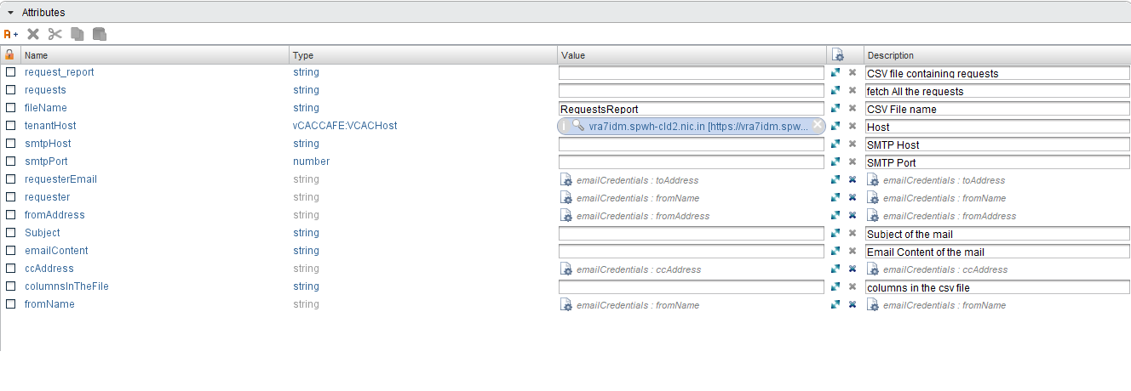

# Future scope

Failed requests can be filter according to organization as well.